BREMBO'S UV-COATED DISCS:
MORE RESISTANCE AND LESS ENVIRONMENTAL IMPACT

Three-in-One innovation
UV technology, a shiny metallic effect and respect for the environment: just three extraordinary features for the latest Brembo innovation. The new coated disc sets a new standard in the coated disc field.

Once again, Brembo is the first company to offer a brand new, highly innovative and avant-garde technological solution to professionals in the automobile aftermarket. As a world leader in the design and production of braking systems for the most important carmakers, Brembo has developed extraordinary expertise in the production of coated discs for all leading vehicle manufacturers. The portfolio comprises all possible variants - from Geomet, zinc and epoxy coating through to the most modern and advanced: UV coating.

Better resistance against corrosion….
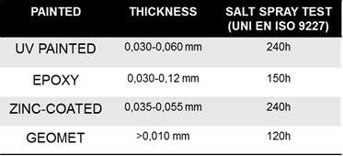
When compared with discs with conventional corrosion protection , UV-coated discs ensure better resistance against corrosion, as confirmed by corrosion resistance testing in a salt spray chamber and moisture resistance tests. UV coating also clearly passes all tests with respect to resistance to high temperatures.

Corrosion resistance test in salt spray chamber
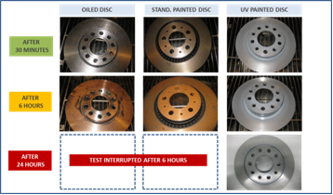

Moisture resistance test

….more practical advantages
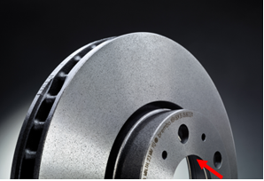
In addition to better corrosion resistance, the protective coating (on delivery even on the braking surfaces) ensures complete product protection through to fitting, which helps mechanics significantly in their daily work by avoiding the need to remove oil from discs, which had been used until now to protect the discs.
What’s more, as the photo shows, a laser mark on the visible face of the hub allows an immediate readout of the minimum thickness envisaged for replacement. During a simple routine check, the car professional is able to recognise whether it is time to change the brake discs.

Aesthetically perfect
Brembo again manages to combine innovative and high-performance technological solutions with impressive aesthetics and styling. In this regard, UV-coated discs are designed specifically for drivers with a keen eye not only for product performance, but also for aesthetic content: the metallic paint, guarantees that these discs always have a bright and pleasing appearance over their life span.

A significant step forward in care for the environment
In recent years, air quality has become an increasingly important issue. The specially developed coating system uses UV light to fix the coating, which produces considerable environmental benefits. The UV coatings are water-based and solvents as traditionally used in epoxy or zinc-bearing coatings do not appear at all. This also applies to so-called V.O.C. emissions (Volatile Organic Compounds) that cause environmental alterations and are harmful to human health. During the UV coating process, the solvent function is essentially performed by water. Since the coat hardening is performed by UV irradiation and high temperatures are therefore not required, energy consumption is reduced. Additionally, the risk of affecting the geometric features on the disc, which may occur with other coatings applied under extremely high temperatures (more than 300 °C), is also reduced.

Range extension
Over the last years, Brembo has tripled the number of coated brake discs - initially only provided to top-of-the-range applications. Most vehicles on the road in Europe can therefore now be equipped with UV coated discs from Brembo, whether top-of-the-range, in the medium or compact segment and equally they can also be applied to recent production cars.

For additional information, please contact Caroline Fallara, Brembo N.A. cfallara@brembo.com or Kyle Chura, Brembo Media, kyle@kcapr.com.

About Brembo SpA
Brembo SpA is the world leader and acknowledged innovator of brake technology for automotive vehicles. Brembo supplies high performance brake systems for the most important manufacturers of cars, commercial vehicles and motorbikes worldwide, as well as clutches and other components for racing. Brembo is also a leader in the racing sector and has won more than 500 championships. Today the company operates in 15 countries on 3 continents, with 26 production and business sites, and a pool of over 11,000 employees, about 10% of whom are engineers and product specialists active in the R&D. 2020 turnover is € 2,208.6 million (12.31.2020). Brembo is the owner of the Brembo, Breco, AP, Bybre, and Marchesini, SBS Friction brands and operates through the AP Racing brand.
###

